Make Even More: Switched Binary Adder
I showed you the switch equivalents of logic gates in Figure 18-1. Since a half adder can be built from an XOR gate and an AND gate, you can represent it with only two switches, as shown in Figure 25-5.
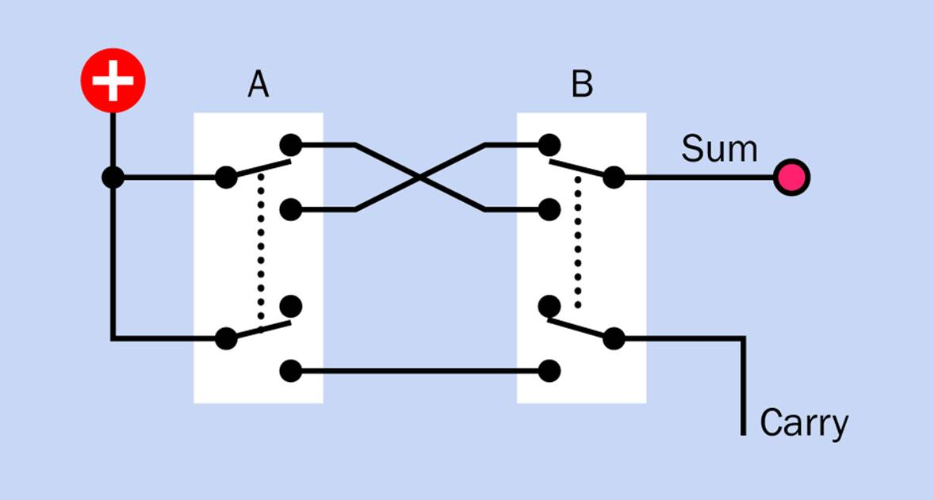
Figure 25-5. The function of a half adder can be emulated with a pair of DPDT switches. A grounded LED, with series resistor as required, should be substituted for the “Sum” indicator.
When switches are used as a substitute for logic gates, an input consists of pressing a switch. So, to enter the binary addition sum 1 + 0, you would close the lefthand switch while leaving the righthand switch open. This correctly gives an answer of 1 by illuminating the LED, with no carry output. And if you entered 1 + 1 by pressing both switches, you’d get the correct answer 10, represented by a carry output while the LED stays dark.
This seems easy enough, but a full adder is more problematic. Refresh your memory of the logic diagram for a full adder by taking a look at Figure 24-5. The top part is exactly the same as the half adder, which I just dealt with. No problem there. But the output from the first XOR gate goes to another XOR, where it is compared with the carry from the previous place.
The problem is, we are now using fingers pressing switches as inputs. But the second XOR only has electrical inputs—nothing that can be pressed by a finger.
Here’s another problem. A low output can be interpreted by a logic gate just as easily as if it were a high output. But when switches are used, a low output becomes an open switch, which cannot be interpreted, because its state is indeterminate.
My answer to both these problems is to have an active “no carry” output from the half adder, as well as a “carry” output. This will provide voltage that each new stage of the adder can either block or pass along.
A revised half-adder schematic is shown in Figure 25-6. The “no carry” output is active if neither switch is pressed, or if either switch is pressed, but not both. The “carry” output is only active if both switches are pressed, so the “carry” and “no carry” outputs are always the inverse of each other.
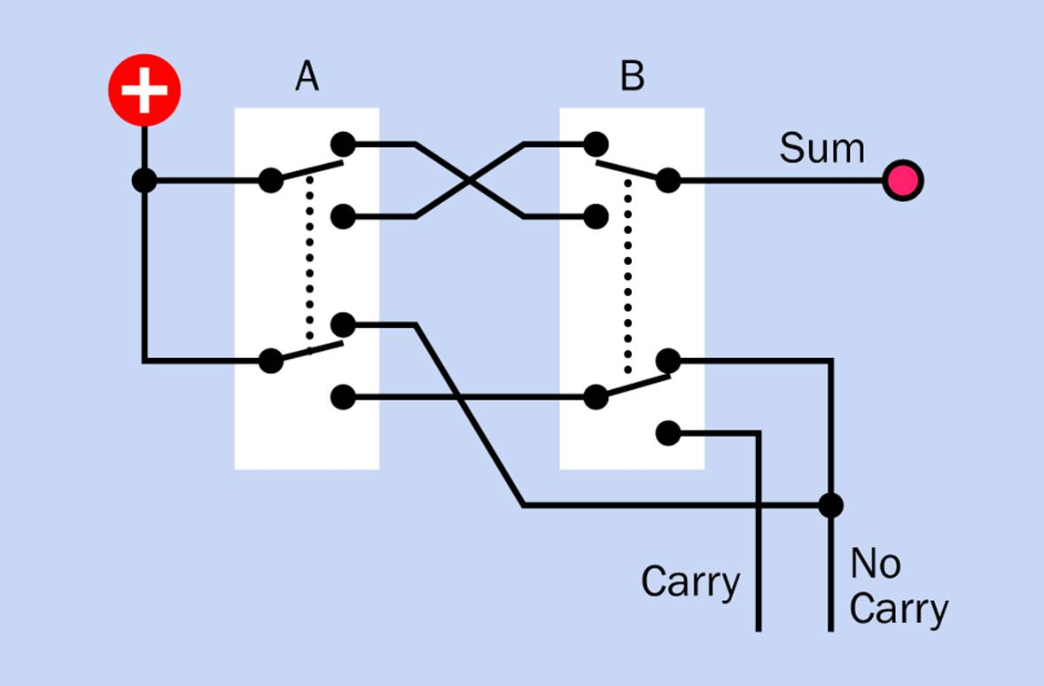
Figure 25-6. The previous schematic for a switched half adder has been revised to include a “No Carry” output to provide voltage for the next stage.
Making a Table
The next step is to nail down exactly what we want from a full adder. To do that, I made a little table, shown in Figure 25-7. This shows the three possible outputs that the adder can create and all the input combinations that can create each output.
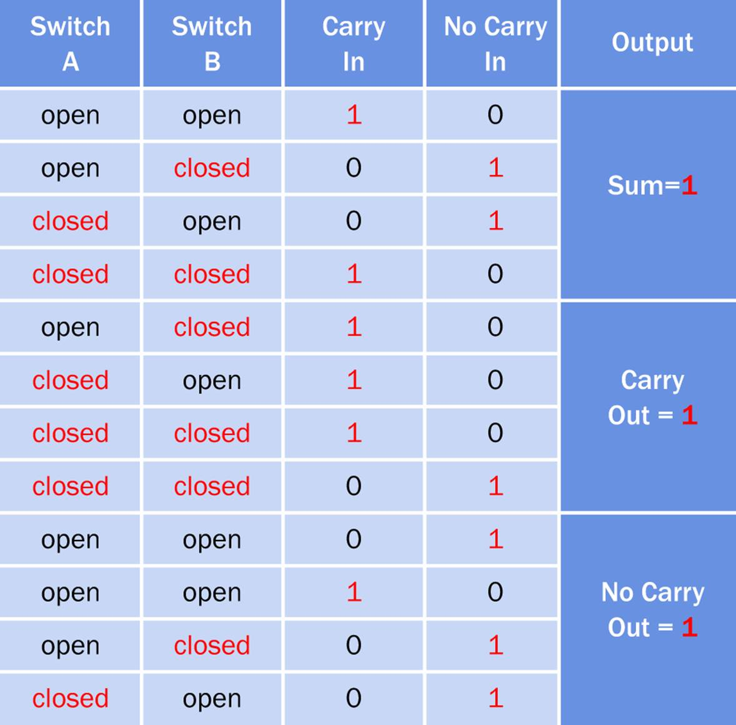
Figure 25-7. The outcomes from a full adder, for all possible input combinations.
For instance, the second line of the table shows that when Switch A is open (representing a 0 input), and Switch B is closed (representing a 1 input), and there is no carry coming in from the previous place, then Sum = 1. The eleventh line of the table shows that the same combination of inputs results in a “No Carry” voltage going out. This makes sense because if you have one switch being pressed, and no carry coming in, there should be no carry going out.
Switch Specification
I was able to figure out (with some difficulty) a pattern of switches that would match the requirements shown in the table. The schematic is shown in Figure 25-8.
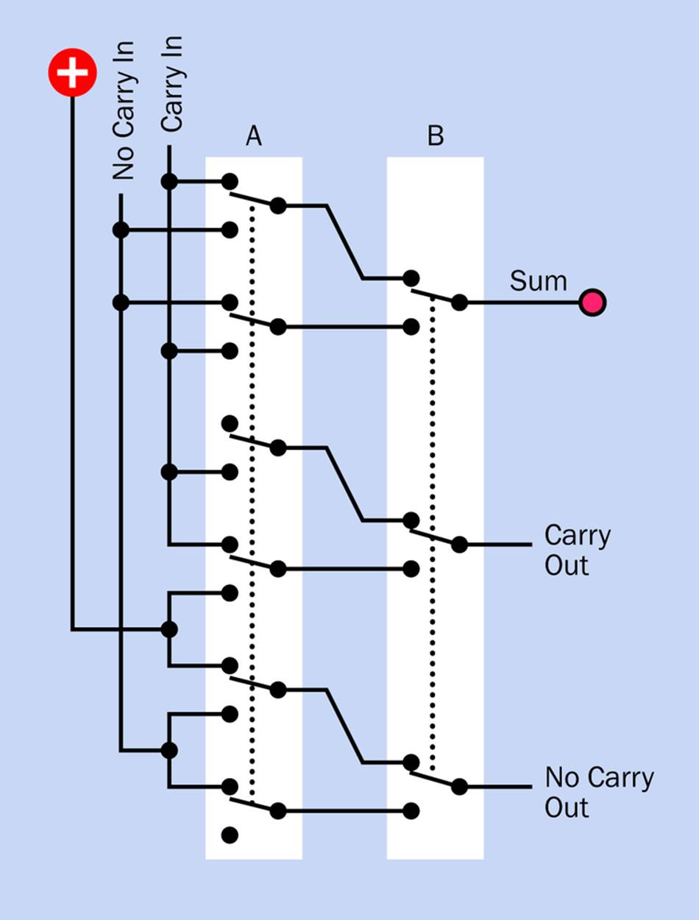
Figure 25-8. A full adder built from a six-pole switch and a three-pole switch, creating the outputs specified in the preceding table.
As you’ll see, this requires a six-pole switch and a three-pole switch. Such switches are readily available in the latching pushbutton format, but I haven’t finished, yet. I want to add an LED to each switch, to show when it is pressed.
This is easy enough in Switch B, because right now it only has three sets of contacts, allowing me to add another set to activate the LED. But adding extra contacts to Switch A would be more problematic, as it already has six poles. Some eight-pole switches do exist, but they tend to be expensive unless you can dig some up from a Chinese source on eBay.
After pondering this problem for a while, I recalled that a computer programmer named Graham Rogers, in England, has always shared my interest in puzzles—and because Graham is almost as obsessive as I am, he created his own switched version of a binary adder a few years ago. I couldn’t find a schematic of it, so I checked with him and found that he and I had come up with the same basic circuit independently. However, he swapped the switch functions that create the sum, which freed up a pole on the lefthand switch to drive an LED.
This revised circuit is in Figure 25-9. It’s not quite as simple as the previous version, but it only requires six-pole switches.
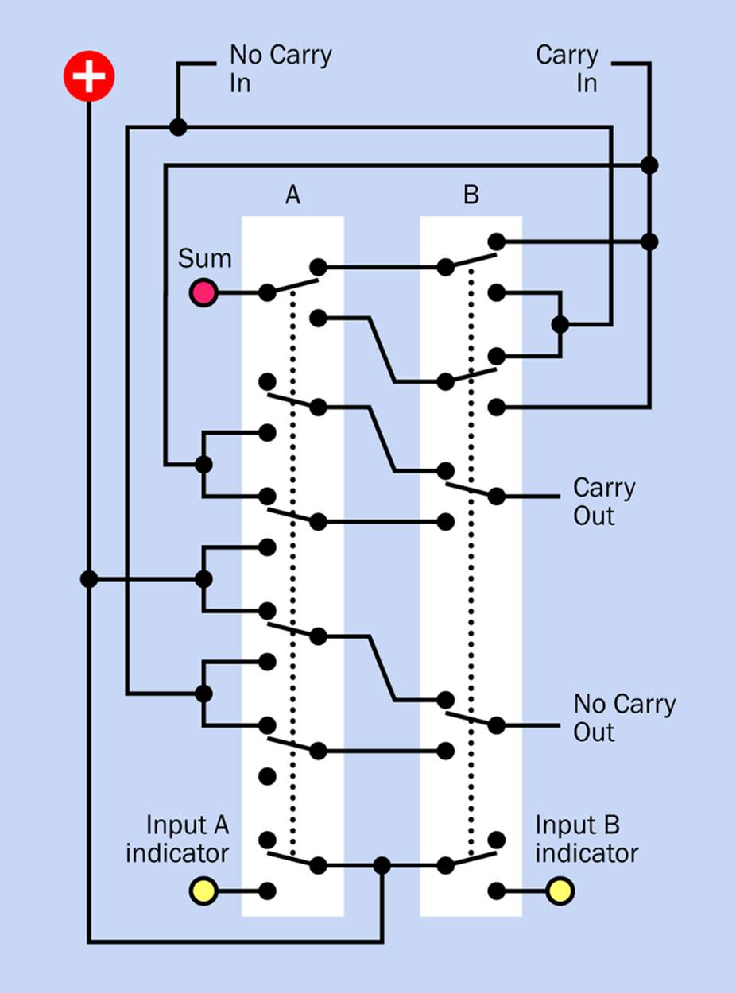
Figure 25-9. Revised schematic for a switched full adder, allowing allocation of an extra pole in each switch for an LED indicator.
You can string together as many of these switched adders as you like, to handle binary numbers of any size. The version that Graham built is capable of adding two eight-bit numbers (two bytes) and can also do subtraction. I can’t remember the rules for subtraction in binary code, so I’ll leave that problem to you.
Make Even More: Other Possibilities
Can the wiring for a switched binary adder be simplified any further? Can the number of switch contacts be reduced? I don’t think so, but I’d like to be proved wrong. If you come up with a plan, let me know.
Now, I can’t resist asking—could we get rid of the OR gates in Figure 25-4 and build an encoder just from switches, to process decimal input and turn it into binary? It should be possible. Any time you see a simple set of gates like those in Figure 25-4, you can feel fairly sure that they can be emulated with switches.
Indeed, this is quite easy. The circuit is shown in Figure 25-10.
The output from this circuit could be used for input to the electronic version of the adder in Figure 24-11, if you don’t mind getting rid of the DIP switches and substituting an assortment of SPST, DPDT, and 3PDT switches.
However, I see no way to interface it with the switched adder. The problem is that in a switched adder, the input switches aren’t just providing input—they’re doing dual duty, performing the arithmetical operations. I’d be very surprised if a decimal-input switched adder were possible, using switches with a reasonable number of poles. On the other hand, I cannot prove that it’s impossible, and human ingenuity sometimes produces amazing results.
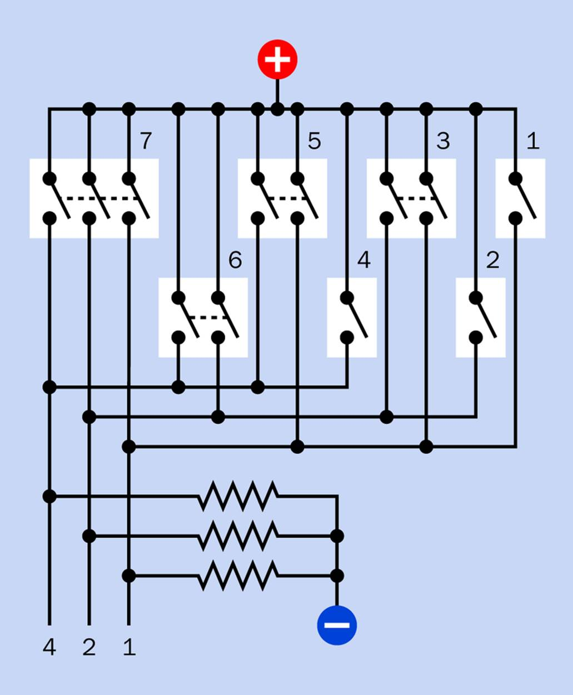
Figure 25-10. The switched circuit shown here would emulate the function of an 8-to-3 encoder chip.
Remember that before the modern era of electronic calculators, adding machines (which could also do multiplication sums) were entirely mechanical. When you looked inside, you found an insanely complicated assembly of gears and levers, and of course the designs were all done with pencil and paper, long before the era of computer-aided design.
Going further back, Charles Babbage’s “Difference Engine” (the first part of which was built in 1832) was a calculating machine, leading Babbage to plan his “Analytical Engine,” a general-purpose, programmable mechanical calculating machine. Vision combined with persistence can achieve remarkable results, if someone has enough time and money to work on a problem.
But I’m going to move on, now, to ring counters and shift registers. These will lead to an in-depth exploration of randomicity, ultimately involving various types of sensors, which will be the closing topic of the book.

